Step 13. Mast Measure up- Vector Calibration
Within this section is necessary for a 3D configuration. You will take a set of measurements that is used by Earthworks to calculate the center of rotation of the machine. This configuration requires the UTS to be set up in the same location as prior points and the machine should not be moved until needed within the calibration process.
Tools Required
Data collector with Siteworks
Trimble SPS9x0 Total Station
Computer with Hexcal (optional)
The machine must be positioned in a place where it can be swung throughout its entire range of rotation.
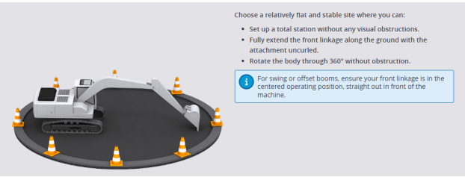
1. Select the measurement method you want to use, the process is quite similar.
Therefore, we have already used the UTS and we will continue with the Total
Station Method.
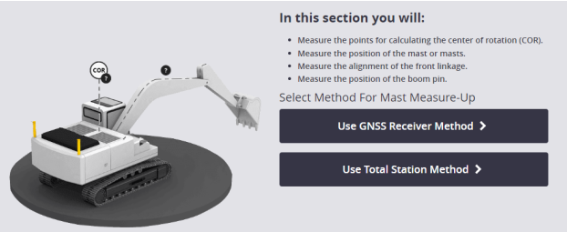
2. Select which type of measure up tool is being used. This will likely be a measure
up tool on top of the receiver however may be mounted directly to a mast.
Select Receiver type.
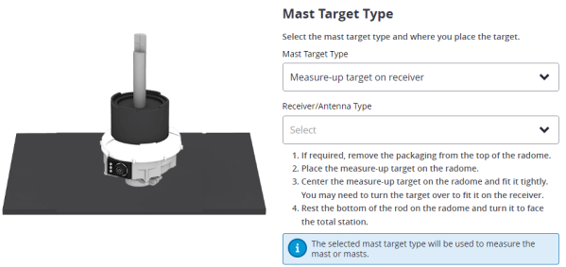
3. Place targets onto the machine, if not already done. Measure up tools on both
receivers as well as targets on pins A and G are required. Hexcal will only be used in this step to determine the horizontal offset between the measured A and G pin and the centerline of the boom. Otherwise, this can also be done by a tape measurement. If the intention is to use Hexcal, it is particularly important to mark the points CT1 and CT2 in the center of the arm.
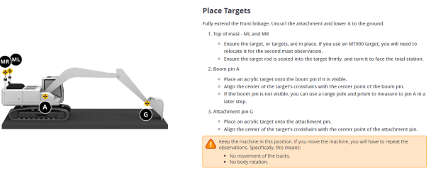
4. If not still done from the previous steps, set up the tripod approximately twice
the machine's full reach away from the machine and perpendicular to the
linkage. Ensure that points ML and MR are visible through the total station. It
may be necessary to remove handrails, etc to gain a clear view of the targets.
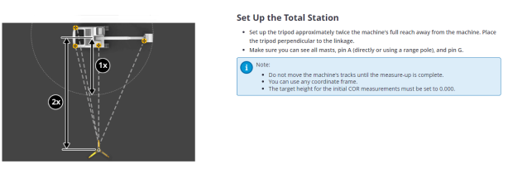
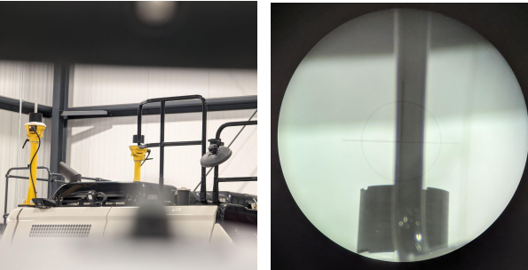
5. If not already done in the previous step for the third machine position, measure
the points ML, MR, A and G. There must be no difference between the
measurement and the actual machine position, as a recording of the roll and
pitch movement of the body is carried out.
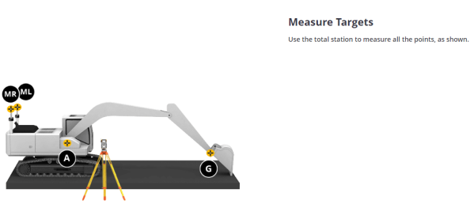
6. Enter the requested Easting, Northing and Elevation of points ML and MR into
Earthworks. For verification the slope distance and elevation difference will be
displayed, these values are not used any further. Finally, click start reading to
determine the body roll and pitch values.
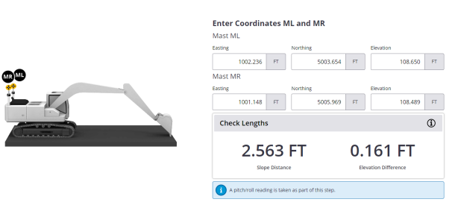
7. Select Boom Pin location and target type
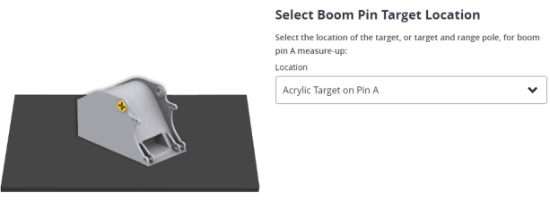
8. Enter the Easting, Northing and Elevation of Pin A into Earthworks, as well as the
horizontal offset. The horizontal offset is the distance from the target to the
middle of the boom. This value can be measured with a tape measure or, if CT1
and CT2 are placed in the center of the boom, Hexcal will provide this value.
For verification the slope distance and elevation difference between ML and A will be displayed, these values are not used any further.
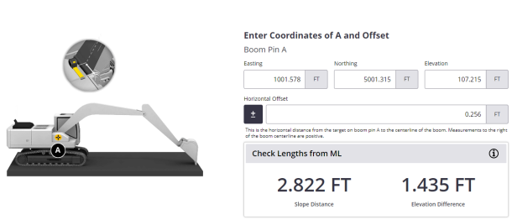
9. Enter the Easting, Northing and Elevation of Pin G into Earthworks, as well as
the horizontal offset. The horizontal offset is the distance from the target to the
middle of the boom. This value can be measured with a tape measure or, if CT1
and CT2 are placed in the center of the boom, Hexcal will provide this value.
For verification the slope distance and elevation difference between A and G will be displayed, these values are not used any further.
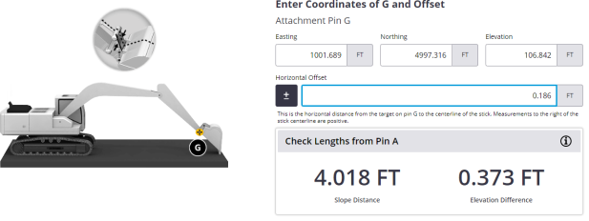
10. At this stage of the Vector calibration, the machine body is going to be moved into 3 more positions and the Easting, Northing and Elevations of these points will be measured.
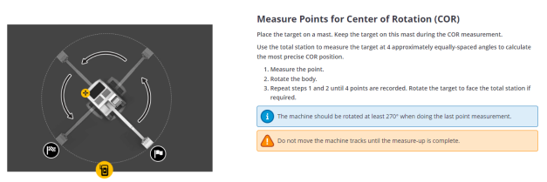
11. The center of rotation (COR), will be the center of a circle formed by 4 measurements done on ML or MR in 4 different positions (~90º between each measurement). The choice of ML or MR makes no difference, it only depends on which target will be best visible in the following process.
The first measurement will be the ML or MR coordinates from the previous step. The machine must therefore rotate by 90° three more times and the same target must be measured again each time.
If a measurement has an error, it will not be possible to calculate the COR from the provided coordinates. In this case, check that the entered coordinates are correct. Otherwise, measure the 4 points again.
